Solar Lesson Plan Format
Age Level: Second Grade
Subject(s) Area: Social Studies
Materials Needed: How to Read a Map Song (http://www.teachertube.com/video/how-to-read-a-map-16699); computer; Elmo projector; “Scott Foresman Social Studies: People and Places” textbook; “Read City Map” Worksheet (one per student); pencils; crayons; whiteboard; whiteboard markers; whiteboard erasers; rubric to grade in-class activities and “Read a City Map Worksheet; and “The Cardinal Directions United States Map” (http://studentweb.cortland.edu/rebecca.winterson/miniproj2/directions.html).
Standards:
Code and description: 2.1.2 Apply map skills (i.e., cardinal directions, map key, symbols) to read a simple map.
Objectives:
What will the students know or be able to do?:
The learner will be able to name the different cardinal directions (North, South, East, and West) and demonstrate an understanding of each of these directions by pointing them out on a map projected on the screen and on the “Read a City Map” worksheet with 80 percent accuracy.
The learner will be able to demonstrate an understanding of how to use a map key and read symbols by finding the place on the projected map and on their worksheets that the symbol symbolizes on the map and map key with 80 percent accuracy.
Cognitive Level of Lesson (Bloom’s Taxonomy): Remembering and Understanding
Learning Activities:
(35 minutes)
- Opening Element: Before I introduce the topic of maps, I will write the following stated objectives on the board and have the students say them with me: “We will be able to name the different cardinal directions (North, South, East, and West) and show we know the directions by pointing to them on the map and on a worksheet with 80 percent mastery.” “We will be able to show we understand how to use a map key and read symbols by finding a place on the map and on a worksheet map that the symbols stand for on the map and map key with 80 percent mastery.” Students will do a turn and talk with their turn and talk partners. One student from each set of turn and talk partners will be called on to state the objectives in their own words. To introduce the topic of maps, students will be shown the “How to Read a Map” Song video (http://www.teachertube.com/video/how-to-read-a-map-16699) (This video is three minutes and forty-three seconds) Differentiation: Musical/Rhythmic.
- Opening Element: (Pages 20-21 of the Social Studies textbook will be projected onto the Promethean board using an ELMO, so all students can see the information and the map in the book throughout this lesson.) Students will be asked, “What do you think a map is and what do you think it does?” (Students’ answers should include some components, but do not need to include all, of the following definition of a map: “Á drawing that shows people where places are located.”) Two student volunteers will be chosen to share what they think a map is and what they think it does. Using parts of those students’ answers, as a class we will create a definition of maps, which I will write on the board.
- As a class we will discuss that maps can show smaller areas, such as small towns, or show larger areas, such as cities. Students will be asked, “Do you see any maps in the classroom?” (Two students will be chosen to go to the maps hanging in the classroom.) Differentiation: Bodily/Kinesthetic. While those two students are pointing out the different maps, the teacher will ask, “Can any of those maps help us to find a place we want to go?”
- “What do you think symbols on a map are for?” (Student answers should include some, but do not need to include all, of the components of the following definition of symbols: “Pictures that stand for certain places on a map.”) Students will have a turn and talk of what they think symbols on a map are for (Differentiation: Interpersonal). After discussing their answers with their turn and talk partners, two students will share with the class what they discussed with partners about symbols. Using parts of those students’ answers, as a class we will create a definition of symbols, which I will write on the board. Two different students will come to the board and point to a symbol on the map on the board (Differentiation: Bodily/Kinesthetic).
- The teacher will ask if the students can find the map key on the board. One student will be asked to come to the board and point at the map key on the map. Then the teacher will ask, “Why is there a map key on the map?” (Student answers should include some, but do not need to include all, of the components of the following definition of a map key: “Shows what the symbols on a map represent.”) Using parts of those students’ answers, as a class we will create a definition of a map key, which I will write on the board.
- To practice using a map key and symbols, the teacher will have one student come to the Promethean board and point to a symbol on the map. The class will need to correctly identify the place the symbol symbolizes using the map key on the map.
- “What do the arrows on the outside of the map show?” (Students will need to refer to the projected pages in the textbook.) (Student answers should include north, south, east, and west.) Two students will come to the board and point to the North, South, East, and West arrows on the map. As each student is pointing to the direction arrows, the whole class will state the name of the direction on that arrow. The teacher will discuss with the students that another name for these directions is cardinal directions.
- For practice with using cardinal directions, the teacher will ask the class, using the projected map, “What direction do you go from Carnegie Hall to get to Central Park?” (North) and
“Is the Skyscraper north or south of the Belvedere Castle?” (South)
- Two students, one at a time, will come to the board and ask the class to tell the direction from one place to another on the map.

- Wrap-Up: Each student will be given a worksheet about reading a city map, which allows them to practice the key points of this lesson. The key points of this lesson are as follows: maps, symbols, map keys, and cardinal directions. (After students are given the worksheet, the teacher will explain the directions on the worksheet to them and what her expectations are for what needs to be completed on the worksheet using the rubric. If there is time, students will be allowed to color the symbols they have drawn on the worksheet map. As students finish this worksheet, they will turn it in during Social Studies class time. When the time has ended for this Social Studies lesson, students will be instructed that whatever section of the worksheet they did not finish will be homework and will need to be turned in the following day. Then, students will write in their daily journals for the next activity.
Assessment:
Formative: A rubric will be used to score the following components:
- Percentage of accuracy attained in the whole group cardinal directions activity and during the whole class map activity using and reading the map key and symbols on the projected map.
- The “Read a City Map” worksheet will be assessed based on the following components included in the rubric:
  - Using cardinal directions to draw symbols of different places in the correct locations.
  - Using a map key to draw the correct symbols for specific places on the map.

Individual Measurability: Each student will be given a worksheet about reading a city map, which allows them to practice the key points of this lesson. The key points of this lesson are as follows: maps, symbols, map keys, and cardinal directions. After students are given the worksheet, the teacher will explain the directions on the worksheet to them and what her expectations are for what needs to be completed on the worksheet using the rubric. If there is time, students will be allowed to color the symbols they have drawn on the worksheet map. As students finish this worksheet, they will turn it in during Social Studies class time. When the time has ended for this Social Studies lesson, students will be instructed that whatever section of the worksheet they did not finish will be homework and will need to be turned in the following day.

Summative: (This activity would be completed at the end of the map unit; however, because I am only teaching this lesson for this unit, I would not give this assessment to the students after this lesson.)
- Create a map of a city and be sure to create symbols and a map key for your map. Also, name your streets. Please write the name of your city, which can be a real or imaginary city, at the top of your map.
- Heidi is trying to find the location of the local community center on the map, but she does not know what the symbol for the community center is. What would Heidi use to find the symbol for the community center? Why?
- Using the map of the United States below and the compass rose, is Montana east or west of North Dakota?

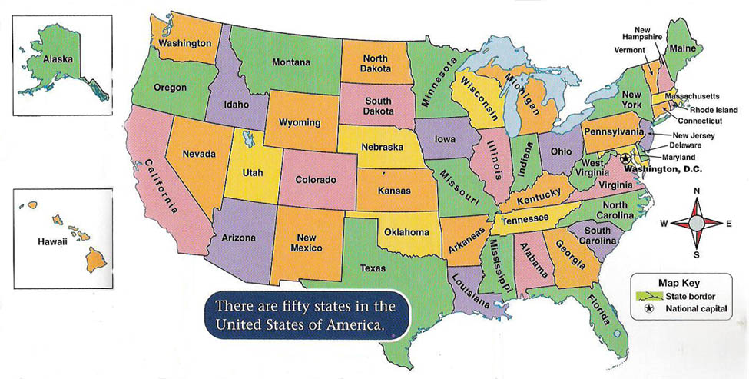
United States Map located at: http://studentweb.cortland.edu/rebecca.winterson/miniproj2/directions.html

Reflection:
When I read and discussed my objectives of the lesson with the students, some of them were confused about my expectations at first. When I explained my objectives to them again, asked two students to put them into own words, which they did successfully, and again asked the class if they understood, they said yes. The students loved the music video and it seemed to engage them in the topic of maps that we would be discussing. In fact, they wanted to watch it again. For the definition of a map, I had the students do a turn and talk with other students next to them. After they had their turn and talks with their partners, I asked some students to share what they had discussed with their partners about how to describe and define maps. The students’ responses told me that they understood what a map was used for and what it was. As a class, we formulated a definition of the word “map”, which was, “Something that can tell you where places are, so you can get there easier.” This also told me that students understood what the word map meant and its purpose. They were easily able to point out the maps in their classroom and identify the correct map that could help us find a place that we wanted to go.
Initially, students were confused about the word “symbols” and some did not know how to explain what they thought the purpose of symbols on a map were to their partners. After their turn and talks, we had a class discussion about the word “symbols” and I used the projected map from the social studies textbook on the Promethean board, which I believed helped them to begin to grasp what symbols were. Once I explained symbols as being pictures on a map and then asked students again what they thought symbols were for on a map, the students were then able to make the connection that symbols were pictures that stood for certain places on the map. When I asked two students to point to a symbol on the projected map, both of them were able to quickly and easily identify the symbols on the map by pointing to them. Due to time constraints, I engaged the students in whole class discussions about the following vocabulary words: symbols and map key rather than writing those definitions on the board. The students were easily able to point to and identify the map key on the board. With some guidance from me, the students were able to answer that a map key helps them to know what the symbols on the map represent. I had one student come to the board and point to any symbol that he chose. After he chose the symbol, the students were able to quickly and easily identify his symbol using the map key. I knew this because they replied in unison as a class.
I thought that using cardinal directions on this map would be difficult for them, but to my surprise they understood this concept quickly! They were able to quickly and easily tell me as a class what each arrow said as well as identify the direction my hand was moving (north or south) from one location on the map to another location. Two students were asked to come to the Promethean board and identify two different locations on the map. The rest of the students needed to determine what direction their fingers would move from that place to another place. The students were able to again quickly and easily identify the correct direction from one of those places to another place. To be sure that they were really understanding concept of different directions, I did the first two problems on the worksheet with them. Again, they were able to do those problems without much difficulty. Through the class discussion and activities, I was able to determine that all the students were able name the cardinal directions and correctly point them out and use them on a map with 90 percent accuracy instead of 80 percent. I was also able to determine from the class discussions and activities that they were able to use a map key and read symbols by correctly finding places on the map that the symbol symbolized on the map and map key with 90 percent accuracy instead of 80 percent. However, there was not much time for them to work on their worksheets, so they were not able to complete them in class today. Instead of taking the worksheets home as homework, the students put them in their work-in-progress folders to finish in class the following morning. Sometimes because of their energy and eagerness and it being the day after Halloween, some of the students had to be reminded during the lesson to do their jobs and listen to what was being discussed during the lesson instead of turning around and talking to their neighbor.
The average rubric score for the worksheets was 15 out of 16 points, or a 93 percent, which was close to the mastery score. The majority of the students scored a 16 out of 16 points, which told me that the majority of them were able to use cardinal directions to draw symbols in the correct locations on the map on the worksheet and draw the correct symbol for specific places on the map using the map key. The lowest score was 7 out of 16 points. The main reason for this low score was that this student was absent the day I taught this lesson due to being sick. Even though I explained the main topics we had discussed during the lesson, he still seemed to struggle with using cardinal directions to draw symbols in the correct locations. Overall, though, I thought this lesson went well and helped the students move toward mastery of the standard and objectives.

Student Name: ________________________________________________________________
Criteria | 4 | 3 | 2 | 1 | points
In-Class Whole Group Map Activity - Cardinal Directions. | Student demonstrates cardinal directions with 80% accuracy. | Student demonstrates cardinal directions with 70% accuracy. | Student demonstrates cardinal directions with 50% accuracy. | Student demonstrates cardinal directions with less than 50% accuracy.
In-Class Whole Group Map Activity – How to use a map key and read symbols by finding the correct place on the projected map. | Student identifies, uses, and reads symbols on the map key and the projected map with 80% accuracy. | Student identifies, uses, and reads symbols on the map key and the projected map with 70% accuracy. | Student identifies, uses, and reads symbols on the map key and the projected map with 50% accuracy. | Student identifies, uses, and reads symbols on the map key and the projected map with less than 50% accuracy.
“Read a City Map” Worksheet –  Use Cardinal Directions to Draw Symbols in Correct Locations. | Student consistently draws the symbols in the correct locations using the cardinal directions given to them for each location on the worksheet with 80% accuracy. | Student frequently draws the symbols in the correct locations using the cardinal directions given to them for each location on the worksheet with 70% accuracy. | Student sometimes draws the symbols in the correct locations using the cardinal directions given to them for each location on the worksheet with 50% accuracy. | Student rarely or never draws the symbols in the correct locations using the cardinal directions given to them for each location on the worksheet with less than 50% accuracy.
“Read a City Map” Worksheet – Draws Correct Symbol for a Specific Place Using the Map Key. | Student draws the correct symbol for a specific place using the map key with 80% accuracy. | Student draws the correct symbol for a specific place using the map key with 70% accuracy. | Student draws the correct symbol for a specific place using the map key with 50% accuracy. | Student draws the correct symbol for a specific place using the map key with less than 50% accuracy.

